====================================================================================================
Set Up Selenium – Web Driver in Java (Eclipse + TestNG)
====================================================================================================

- Download the following packages
  - jdk-7u17-windows-i586.exe
  - selenium-java-2.25.0.zip
  - Eclipse IDE for Java EE Developers
- Install JDK, then configure System Environment Variables by adding a new variable as screenshot
  - Variable name: Path
  - Variable value: ;C:\Program Files\Java\jdk1.7.0_17\bin
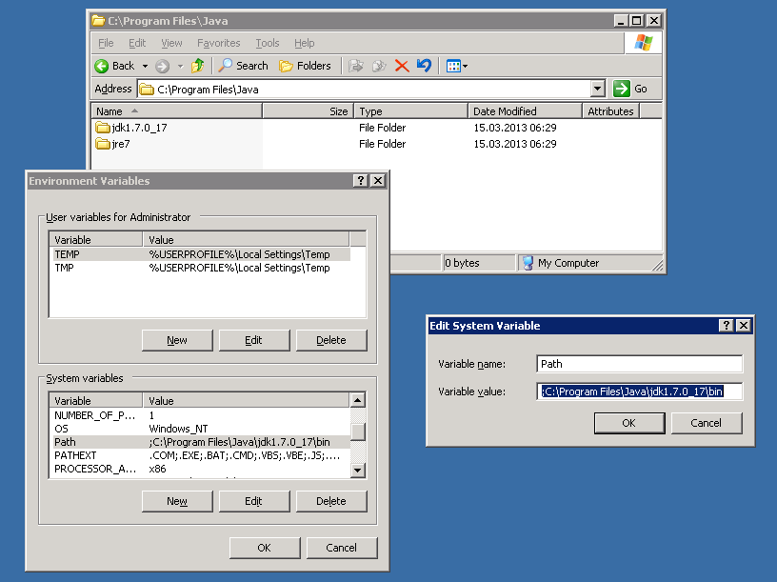

- Run Eclipse, then install TestNG for it (Menu Help > Install New Software …)
  - Work with: http://beust.com/eclipse
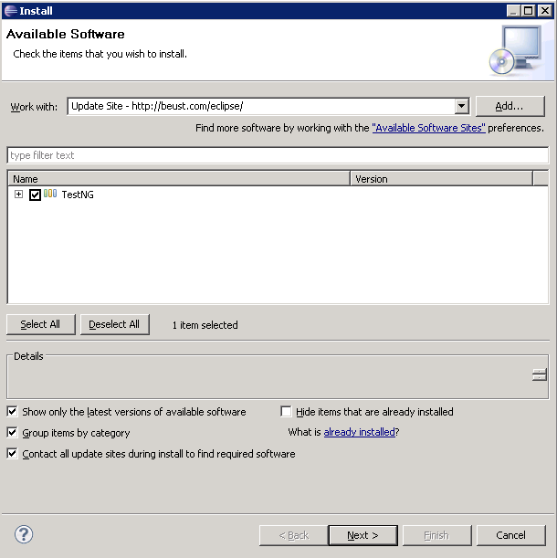

- Create a new Java Project (File > New > Java Project)
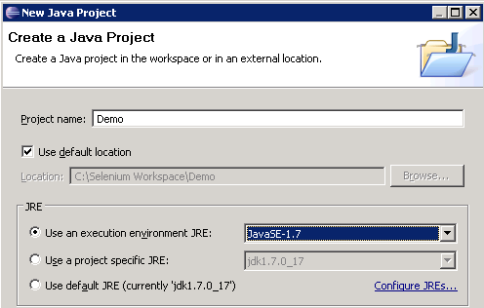

- Extract selenium-java-2.25.0.zip, add all of them into Eclipse – Referenced Libraries
  - selenium-java-2.25.0.jar
  - selenium-java-2.25.0-srcs.jar
  - All Jars into folder Libs
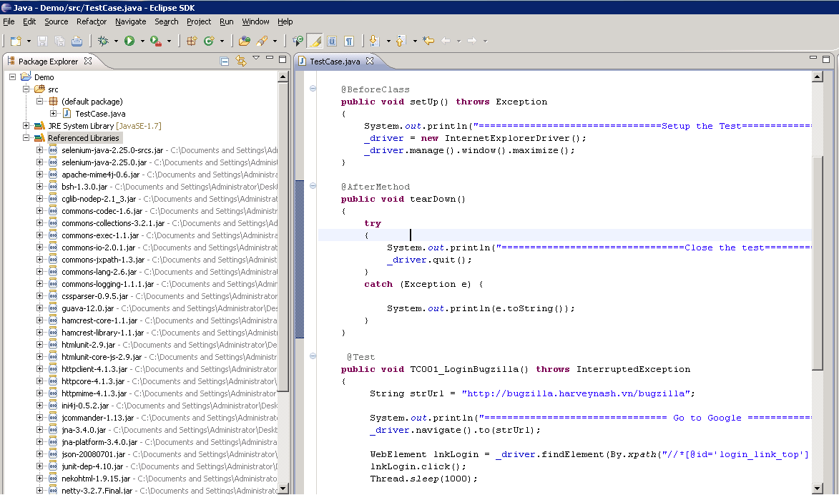

- Create a new Class and write code as example
- Run Tcs with TestNG

